**<https://www.secondroad.com.au/heuristic/acdb>**

**A-Exploration**

*Don’t ‘define the problem’ – reframe the situation*

‍



In the A-Space the cognitive model is ‘**exploration**’ and the object of our thought is the ‘**situation**’

‍

‍

**Think ‘situation’ not ‘problem’…**

Compelling arguments begin with the present situation, not with solutions and not with objectives. A ‘situation’ is broader than a ‘problem’. A ‘situation’ occurs when a social system is at a tipping point or a crossroads. It has become unstable and the fundamental assumptions are changing. The situation represents a change in circumstances that challenge the underlying purpose of the organization or the system.

**Think ‘explore’ not ‘define’…**

You ‘define problems’ but you don’t ‘define’ situations.  You explore them to build a broader picture of what is happening that lifts everyone’s vision above the day to day operations and gives them a sense of the strategic possibilities latent in the situation. The key output is a “rich picture” of the situation. The analysis gives you inputs into the rich picture but does not create it.  The ‘rich’ picture must tell a story about the present situation that both excites and disturbs us.

**Create tension …**

The overall effect must be to reframe the situation as pregnant with potential. This will be the beginning of intellectual momentum. Are we at a tipping point?  Are we at a crossroads?  To build momentum, this ‘crossroads’ needs to be defined in both positive and negative terms.  It is important to identify what is both problematic and promising in the present situation – and to create a sense of urgency. People must be left with the urgent sense that if we do nothing, we will miss a big opportunity.

‍

‍

**B-Imagination**

*Don’t just ‘set objectives’ – dream of a desirable future*

‍



The B-Space cognitive mode is ‘**imagination**’ and the object of our thought is **‘a desirable future’**.

**Think ‘vision’ not ‘targets’**

If you only diagnose the present situation, you don’t have an argument – you just have a therapy session.  To create momentum, we need to develop a vision and ambition. A target is not a vision because it does not create a picture and does not appeal to people’s values and desires. In the B we build a vision of what is possible and desirable. Most organisations and strategies are weak around the B because it requires imagination and skill to describe since it has not happened yet.  You cannot start a movement without a vision.

**Think ‘imagine’ not ‘predict’**

The B space is an exercise in the imagination. When we imagine things, we create images (as the word implies) of situations that do not yet exist. People must find this imagined future desirable.  Strong visions attract human beings because we are teleological creatures.  ‘Telos’ was the Greek word for ‘end’ – not in the sense of a finish line for a set of events, but rather in the sense of a culmination of present energies into a meaningful community.  So the B is a picture of the ‘end’ or the flourishing of an organization or social system.

**Think ‘possible’ not ‘probable’**

Great B’s must be possible but not probable.  In other words, we won’t drift towards them, and they won’t just emerge naturally.  So they must seem just out of reach.  They can’t be ‘impossible’ like a science fiction fantasy – they must be grounded in enough reality to be possible but not probable. That means they will be a little bit scary and unattainable.  They must exist just at the outer edge of our expectations.

‍

‍**C-Invention**

*Don’t ‘brainstorm solutions’ – invent ideas for change*

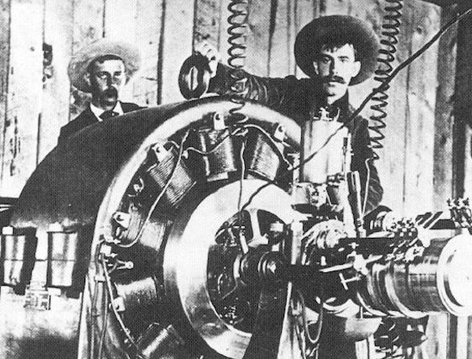

The C-Space cognitive mode is ‘**invention**’ and the object of our thought is the ‘**ideas**’

‍

**Think ‘levers’ not ‘lists’**

In a great C space, you look for levers not lists. “Levers” are the holy grail of smart strategic thinkers because they can achieve benefits that far outweigh the efforts involved. In contrast, a “list” of activities has no big idea behind it and is more a war of attrition where we throw efforts and resources at a problem in the hope that it will cover all the bases. Levers, on the other hand, are smart and targeted and don’t try to change everything.

These levers have the character of a hypothesis because we don’t yet know if they will work.  A hypothesis is a good idea, that is not yet proven.

**Think ‘invention’ not ‘solutions’**

The C space is very much the arena of human invention and judgment.  This makes C space, the arena for ‘design’. A ‘design’ is not a just ‘solution’, it is more like an architect’s blueprint for something we will build.   An architect does not try to find the one right solution to a building concept in the same way that a forensic investigator tries to find the cause of an aircraft crash. The architect uses invention tools to generate concepts whereas the investigator/scientist uses rigorous cause and effect reasoning to identify what really happened. This makes the C space a place for invention, not analytics.

**Think ‘judgment’ not ‘proof’**

Good design is not just creativity, it requires choice. So the other half of invention is judgment.  This means that we also need to invent the success criteria to guide our options.  The judgment is where analytics and evaluation come into the picture.  We need to ask ‘What would have to be true?’ for this idea to be valid. However, we cannot ‘prove’ these ideas immediately – we have to test them in action.

‍

‍

**D-Momentum**

*Don’t ‘brainstorm solutions’ – invent ideas for change*

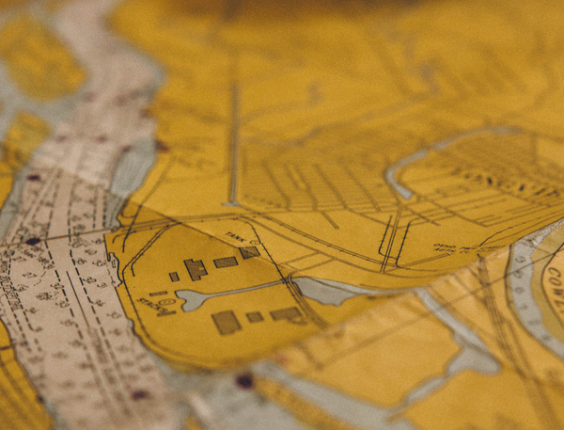

The D-Space the cognitive is ‘**planning**’ and the object of our thought is ‘**change**’. mode

‍

The D space is the territory where we need to plan. However, we are not planning a mechanistic process, like building a bridge; we are planning a socio-technical change. That has massive implications for what we should include in our planning and how we should go about it.

**Think ‘play and learn’ not just ‘plan’**

The D involves action not thought. But it is action to learn because we often don’t know for sure whether things will work in uncertain landscapes so we will only know by trying them. Hence playing and learning, is a much better way to characterize the D space in an argument. Leaders need to declare space for the organization to play and learn – and to make mistakes.  They invite an era of adventurousness and experiment and they reframe ‘failure’ as an opportunity to learn.

**Think ‘momentum’ not ‘implementation’**

In a stable world, ‘implementation’ works because the ideas that we are implementing are predictable and can guarantee results.  But in an increasingly volatile world, we need more dangerous ideas, ideas that could cannabalise our traditional business.  However, a full-scale implementation of dangerous ideas is foolhardy and rash.  So people freeze and don’t do anything because they are caught between ‘implementing’ something or not.

A much wiser way to think about action is that we need to get some momentum going.  Momentum has energy and a direction of its own and it also feeds itself. So the real question for any leader is how can our argument start some momentum?  One of the best change agents we have ever worked with believed a lot in disturbing the waters in the D space.  He thought that the best way to create momentum was to ‘smash a system’ or do something the symbolized disruption or change.

The D will require courage and commitment.  In the D we move out of words and ideas into action.  This will require investment and resources.  And these ‘resources’ will be more than just financial; it will include the authority to act in new ways.  People are always watching the D space to see if leaders are serious about change.