
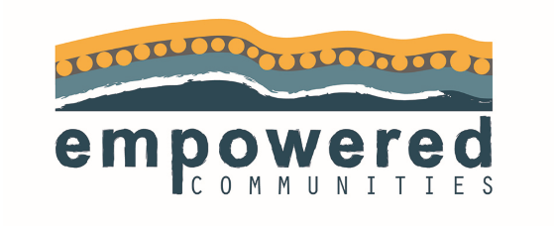
Journey Tracking Tool
Region:
Focus:

Where did we start?

Timing: | Community Engagement | Planning | Co-design | Capacity Development | Investment | Implementation

